Example Animal Sponsorship Agreement Form

Zoo Animal Sponsorship  Agreement  Form | 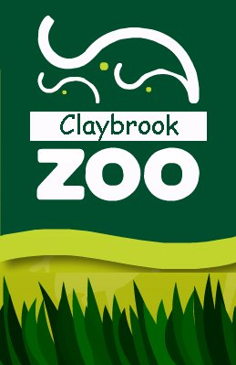
Client/Company Name | Zenth Staybrite Ltd
Existing Customer | Yes/No | ID (If appropriate) | SP1021
Primary  Telephone Number | 01966 7855121 | Secondary Telephone Number | 0800 3289395
Client Address/Contact Details | Mrs Jane Woods (Senior Accountant)  45 Blackwood Road  Westhills  Longbottom  North Yorkshire  NY12 D454
Animal(s) to be sponsored | Redwell and Mango
Animal location | MC1-A1
Sponsorship Band(A-E) | A
Total Price | £2500 x 2 (£5000)
Period of agreement | 1st January 20 11 to December 31st 201 1
Signage % Area | 1/8
Signage Displayed  (Picture of actual agreed content) | 
Special Notes/Requests | Sponsorship details to be displayed in the bottom right-hand corner.
Customer Agreement | By signing the agreement, you are confirming the following to be true:-  - I agree to sponsor the above named animal(s) for the period specified above.  - I understand that the sponsorship fee is due in full by the 30th November 2010 and I will ensure that this fee is paid to Claybrook Zoo Ltd by this date.  - I understand that all sponsorship fees are non-refundable.  - I agree with the above signage layout/dimensions and understand these cannot be changed once the agreement has started.  Signed : J Woods  Dated : 12th October 2010
OFFICE USE ONLY
Payment Details | Electronic Transfer of Funds to Zoo Sponsorship Account
Payment Received:  Sponsorship Review Date: | Yes  1st October 2011
Signed/Date | J T Rodgers

